RX12

Manual

Version 1.0

August 2019

Table of Contents

1. Overview
2. Connections and LED codes
3. Binding
4. Client software
5. Data logging

Overview

The RX12 receiver turns one or more DSMX/DSM2 satellite receivers into a full capability receiver with up to 12 channels. It supports the following features:

* 22ms or 11ms output frame rate
* Configurable no throttle or user preset failsafe
* Can support up to three satellite receivers for full diversity.
* Limited data logging.
* Updatable firmware.

Connections and LED codes

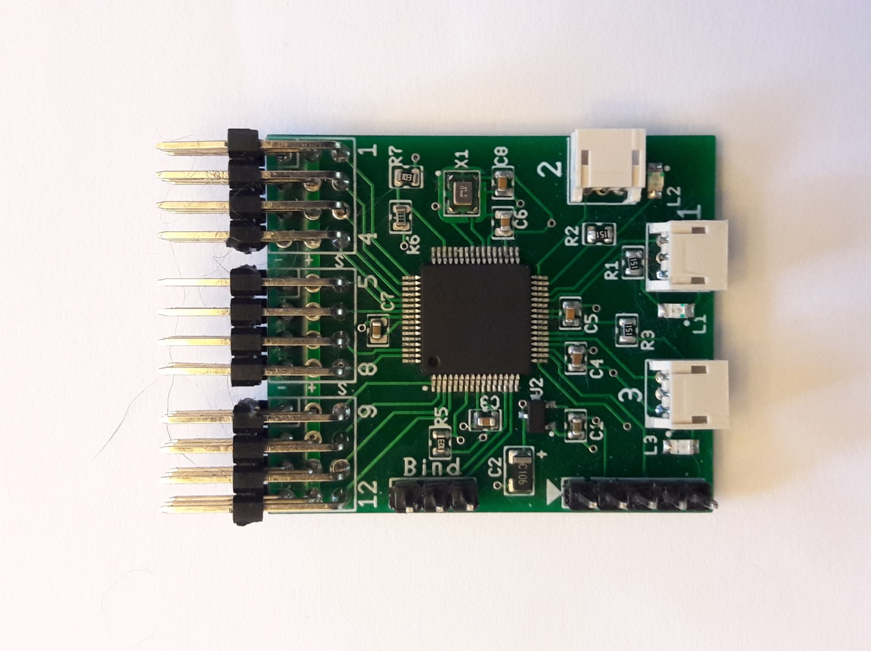

Tx Gnd Rx

Satellite Ports

L1, L2 and L3 are LED1, LED2 and LED3

ICSP Port

Bind/Serial Port

Servo outputs

Connection descriptions

Satellite ports: Connect one or more DSMX/DSM2 satellites to these ports. Any port may be used, they do not need to be connected in any order. You can connect satellites to any combination of ports. The only requirement is that all satellites must be of the same type, either all DSMX or all DSM2. Each port has an associated LED for status indication.

Bind/Serial port: Used to bind the receiver to the transmitter and for serial communication to a PC. See the Binding section of the manual for information on binding. See the Client Software section for information on serial communication.

ICSP port: Used to update the firmware. Not normally used.

Servo outputs: Connections to the servos. Channel 1 is the upper pin in the picture and Channel 12 is the lower pin. Channels 11 and 12 can also be used during the binding process. See the Binding section for details. The signal pin is the upper pin (or rightmost on top pin versions). The ground pin is the bottom (or leftmost) pin. The center pin is power.

Led codes

LED1 On solid = satellite connected and receiving data

LED2 On solid = satellite connected and receiving data

Two flashes at startup = Preset failsafe mode

LED3 On solid = satellite connected and receiving data or serial connection established

Two flashes at startup = 11ms frame mode

10 flashes at startup = bind mode

Binding

To bind the receiver to a transmitter follow the steps below.

1. Connect one or more satellite receivers to the satellite ports.
2. Place a bind plug on the bind connector.
3. If you are using DSM2 satellites place a bind plug on Channel 11.
4. If you want to enable 11ms frame rate output place a bind plug on Channel 12. This can also be enabled at a later time either with a bind process or with the PC software.
5. Connect the receiver to an ESC or battery. LED3 should blink rapidly 10 times and the satellites should blink to indicate bind mode.
6. Place the transmitter into bind mode and complete the bind. DO NOT unplug the bind plug at this time unless you want to enable preset failsafe (see next step.)
7. To enable the preset failsafe do the following. Go to step 8 for normal failsafe.
   1. Use the transmitter to set the servos in the desired positions.
   2. With the servos in the correct positions remove the bind plug.
   3. You can now power off the receiver.
8. For normal failsafe (no signal to throttle, all other channels hold) remove the power from the receiver BEFORE removing the bind plug. Don’t forget to remove the bind plug!

To enable/disable 11ms frame rate after the receiver has been bound:

1. Plug a bind plug into the bind port.
2. Plug a bind plug into Channel 12 to enable 11 ms mode. Leave Channel 12 open to disable 11ms mode.
3. Power the receiver. LED3 will blink 10 times and the satellites will be in bind mode.
4. DO NOT rebind the transmitter. After the receiver quits blinking remove the power THEN remove the bind plugs. The next time the receiver is powered up it will blink LED3 twice to indicate it is in 11ms mode.

Client Software

The receiver can be connected to a PC through the bind/serial port. The client software can be used to read or set some of the configuration settings. It can also be used to retrieve data logged during previous flights. To connect the receiver to a PC you will need a USB to Serial bridge that supports 3.3V levels.

To connect:

1. Make sure the USB to Serial adapter is set for 3.3V. A 5V adapter will damage or destroy the receiver.
2. Connect the ground of the adapter to the middle pin of the bind port.
3. Connect the TX of the adapter to the RX pin of the bind port.
4. Connect the RX of the adapter to the TX pin of the bind port.
5. Plug the USB to Serial adapter into your computer.
6. Connect an ESC or battery to the receiver. LED3 should light up and remain on.
7. Start the client software.
8. Select the Connection menu and from the Port menu select the port that corresponds to your USB to Serial adapter. The status bar at the bottom of the window should show that you are connected.
9. Click the Read button to read the settings.
10. Make any changes you want and then click the Save button to save them to the receiver.
11. To download flight logs change to the Data tab. Select the number of logs to download (starting with the most recent) and click the Load button.
12. Clicking the Reset Log button will clear all current logs and restart the numbering at 1.

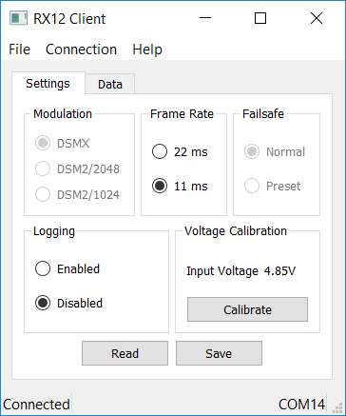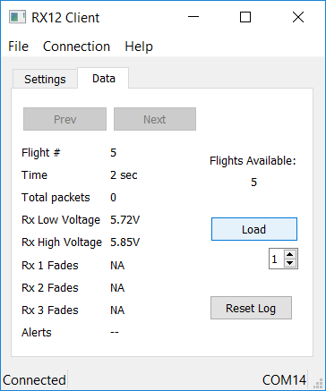

Voltage Calibration

The voltage input must be calibrated before it will give meaningful results. You can do a one point or two point calibration. A two point calibration is more accurate but requires two different voltages with at least 1.0V difference. A 2.0V or more difference is recommended. This will require a variable power supply that can be connected to the receiver

To perform a one point calibration:

1. While connected to the serial adapter and powered on accurately measure the input voltage to the receiver.
2. Click the calibrate button.
3. Enter the measured input voltage in the dialog.
4. Click Next
5. Click Single Value to complete the calibration.

To perform a two point calibration

1. While connected to the serial adapter and powered on set the input voltage to the receiver to a known value between 4.0V and 12.0V.
2. Click the calibrate button.
3. Enter the input voltage in the dialog.
4. Click Next
5. Set the input voltage to a new value. It can be higher or lower than the first voltage but should be at least a one volt difference. It is best to use voltages that cover the expected operating range of the receiver.
6. Enter the new input voltage in the dialog.
7. Click Next to complete the calibration.

Data Logging

If enabled the receiver will log the following data for each time it is powered on:

* Power on duration
* Total packets received by all satellites
* Input high and low voltage.
* Fades for each satellite.
* Any error conditions detected including activation of the failsafe feature.

Notes:

* Data is sampled continuously but is only saved to flash memory every second.
* In the event of a power failure or brownout the last second of data may be lost.
* Voltages are checked every millisecond.
* Fades are recorded with each satellite packet.
* It is not recommended to use data logging for every flight. Continuous use will eventually wear out the flash memory used to save the logs. This will not affect the operation of the receiver but will prevent any more logging. Just turn on logging when you want to see how the receiver is functioning in a new setup or with a different satellite configuration etc.

Alert Codes - The following codes may show up in the Alerts display:

* FS = Failsafe

The failsafe engaged at some time during the flight. This means none of the satellites had a signal at some point.

* WD = Watchdog

A watchdog reset occurred. This is bad. It means the code locked up at some point. Report this to the designer.

* CF = Clock Failure

The on board oscillator has failed and the backup internal oscillator had to take over. The receiver will still function but may not be fully reliable. This should almost never happen but if you see this error it is recommended to replace the receiver.